Wise Words February 16-23
Gary Wise
All right. The first Wise Words was prim and proper, a stoic, factual recounting of the Magic year's major events. Articles like that one are important because they preserve time. Ten or twenty years from now, we can look back, read that article and get a general feel for what happened in Magic's 2000. Now we get onto the fun stuff.
Wise Words, much like the short-lived Limited Skills, is mostly going to focus on the behind the scenes goings on of the Pro Tour and its participants, at least as seen through the eyes of yours truly, with occasional strategy thrown in. No, I'm not going to start frantic finger pointing and the like, but I will tackle internet issues from time to time and keep you all informed of PT goings on. Who's working with who, or more importantly, who isn't... these things fascinate me, so the idea here is to keep you as informed as I am.

EA-Kobra Kai
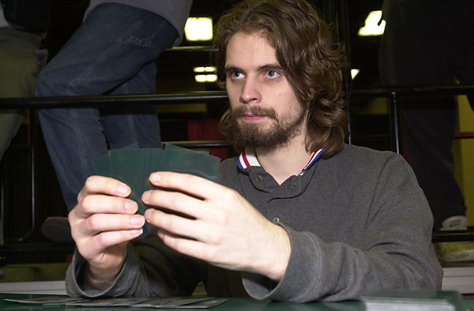
Kilimanjaro or no?
One of the biggest team ups for Tokyo seems to be the pairing of two major teams on tour, Kobra Kai, (Scott Johns, Zvi Mowshowitz, Brian Selden, Seth Burn) and the remnants of European Alliance (Kai Budde, Patrick Mello, Warren Marsh, Ben Ronaldson) have teamed up for Tokyo, but word has it that even this strong group of deck builders have been unable to break the format, suggesting Tokyo will be more like last May's Rebel-Waters infected PTNY than the previous year's Academy-laden PTNY.
Interesting note here: Ronaldson, went almost directly from PTLA to Mount Kilimanjaro. Ben described the experience as containing the best and worst days of his life, but when he reached the peak, his true nature showed: he screamed out "FIREBLAST" and buried a Magic card there.

Huey, Ben and Casey
What was once the up and coming teams is no more. With the memory of McCarrel's late showing for Day 2 of NY costing them a match and potentially Day 3, Billy Jensen and Ben Rubin played with the idea of finding a new third. When no immediate answers revealed themselves, Billy decided to take things a step further and team up with Matt Linde and Brock Parker, with who Billy has been doing a lot of drafting, leaving Rubin teamless.
Not that Rubin had any reason to worry. With a Masters victory and two Top 8 finishes in the last year and a half, Ben is obviously one of the most respected players on Tour. With potentially his choice of teams, it appears that he may choose to play with Dave Price and Mike Bregoli, leaving Casey scrounging for teammates. Maybe he'll look up Matt Vienneau who, with Price apparently joining up with the Americans and Gary Krakower narrowly missing his needed Top 32 in LA to stay on the gravy train, now finds himself without a team. Expect a 40-page rant from Vienneau shortly.

Fear
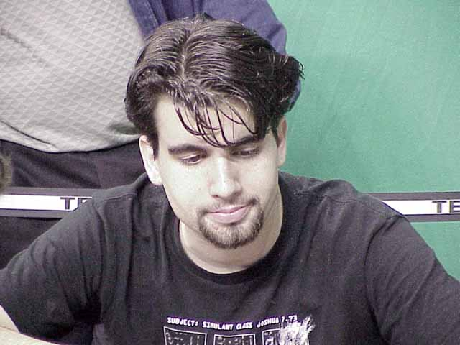I had a conversation on this week where I was told that Ed Fear had done the right thing in printing his retraction. The logic went that, while Ed had obviously made a mistake in posting his original rant, he's made things right by making the retraction. Anyone else see the flaw in this argument? Here we have a player who made a clearly illegal move, regardless of whether it was intentional or not. He makes a mockery of the game's governing body, pointing each of his fingers in any direction not already covered. He riles up the entire online community, creating a domino effect in which everyone believes everything they read and write accordingly, and then, after taking a look at the evidence weighed in his case apologizes for inconveniencing everyone, says the DCI did a fine job, finds no fault in their logic for giving him one of the heftier suspensions ever handed down, and still maintains his innocence. Something's rotten in the state of Denmark, folks, and it isn't a regal corpse.
Regardless of the degree of his guilt, Ed acted in a totally irresponsible manner through this entire ordeal. First, in posting without all the facts in front of him, then allowing the community to respond in kind, and finally in the confused ramblings of his retraction. The damage done to the DCI, who in truth is not accountable to me, you, or anyone who posted their thoughts on the matter, is still done. Time and again, we question the DCI's decisions with regards to leniency and the like, but with their decision to hand down a sizable penalty for a sizable offense, the community that should be supporting the elimination of illegal actions which serve to delegitimize the game, instead of turning on Chris Zantides, Jeff Donais and the rest of our governing body. Ed's retraction is the first step towards healing the damage here, but it in no way exonerates him in this matter, nor does it pardon those who bought into his soap box confessions. I hope I'll be seeing many more retractions on the matter.

Tokyo team ups
With another Block-Constructed Pro Tour upon us, it dawns on me just how important it is to work with a large number of top-caliber players. When looking back at the last two Block-PTs, one has to notice that twelve of the sixteen players who made Top 8's in those tournaments belonged to four teams: YMG, Jumble, Mogg Squad and EA.
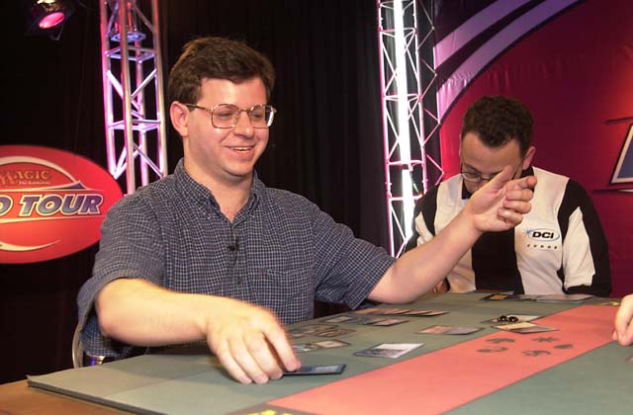
With the need for a strong team so fundamentally obvious going into Tokyo, players who don't have the option of working with those groups are banding together in some unusual team ups. The most notable of these has to be Team Rejects, which is composed of a number of players who at one time or another have been members of either now-defunct teams or teams that have discarded them. Mattias Kettil and Mattias Jordstedt, formerly of EA, have teamed up with Alex Shvartsman, who has worked with both EA and Jumble in the past and Mike Pustilnik to form the core of this team who worked together for Chicago. Pustilnik is not a big fan of online testing, so the majority of his time will be spent working with Alex and polishing his PTLA trophy. Also in the group are Trey Van Cleave, characterized by Randy Buehler as one of the best metagame deck-builders on the planet, Jakub Slemr, formerly of Mogg Squad and Brian Davis, who worked with that now-defunct team for this year's World Championships, where he finished 9th
Meanwhile, the EA disintegration has left a number of smaller teams in the Kobra-Alliance wake. Dominik Hothow of Worlds semi-finals fame will be working with the newly retired Dirk Baberowski and former German Champion Marco Blume, while both Stephan Valkyser and Christian Luhrs, have decided to skip the tourney altogether. Meanwhile, a team of Englishmen including Worlds Standard Champion Scott Wills and Tony Dobson have conglomerated, while a new Scandinavian team called Team African Alliance, which includes Erno Ekebom, Nico Herzog, Arto Hiltunen and a host of others that could possibly include The Big Viking Sigurd Eskeland looks like it'll be forming.
One other major team that looks to be shaping up is one the involves just about every major European pro not already listed here. It starts with Ryan Fuller and Noah Boeken in the middle of things, working with Kamiel Cornelissen and the rest of the Dutch. Throw in the French led by Raphael Levy and Ruel brothers, Chris Benafel and the rest of his AlphaBetaUnlimited teammates and a host of others and you have what could prove to be a major force in Tokyo. The big question here will be how effectively so many loud voices work together, with past experiments in this size of team having disappointing results.
On American soil, the biggest question seems to be where Steve O'Mahoney-Schwartz will be doing his testing. Living in Boston for school, Antarctica's rival YMG has opened their doors to OMS, with the big question being whether his brother Dan and Jon Finkel will be able to work with the New Yorker should he decide to work with the Bostonians. SteveO says he won't abandon his Antarctica teammates, but its up in the air as to whether they'll be working with the rest of their playtest group from Chicago. Jon has been seen online testing with Brian Kibler, who is working with Ben Rubin, Bill Jensen, Matt Linde and Brock Parker.
Also on the North American front, one team to watch appears to be that being headed by Michigan's Eric Taylor. Working with comeback kid Pat Chapin, Aaron Breider and other Michigan types, this team gets really interesting when you throw some Tight Tommy Guevin into the mix. Tommy has already gone AWOL, leaving the rest of his teammates wondering if they're actually teammates at all. I'll keep you posted.

Kamiel
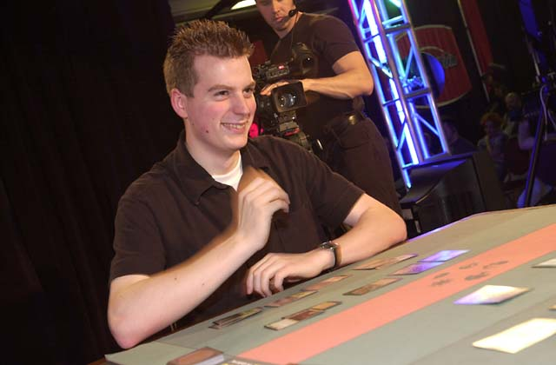
The next Budde? The next Finkel? The first Cornelissen? All of the above are being said about the kid who is heading the new Dutch insurgence on the Tour. Take a look at what Kamiel has done in four PT appearances. He started with an 11th place finish in May's PTNY, removing him from eligibility for this year's Rookie of the Year race. Then he finished in 23rd in the August PTNY, teaming with his brothers Jesse and Stijn to finish ahead of Antarctica amongst others. Then, he goes to his second Constructed PT and finishes second, beating Finkel in the Top 8, which he also then did at his first Limited PT LA, finishing second once again.
That's insane. Think about what this guy has done! In three individual PTs, he's averaging a 5th place finish. Not since Scott Johns way back in the PTs first season has a player made two consecutive Top 8s in their first year on the Tour, and NO ONE has ever made two consecutive PT finals. Ever.
Kamiel may be the next big thing on the Tour, but there'll be a lot of pressure now with the entire World watching.

Tokyo Masters
OK, the Tokyo Masters is just about set. As I understand it, these will be the seven teams (in order of rank) who will be competing with the Gateway winners for their share of $156,000:
Your Move Games: Darwin Kastle, Rob Dougherty and Dave Humphreys. Well, ever since the teams format was introduced to the big time, everyone and their brother knew that these three would play together always. Darwin is the most accomplished soloist on the team with his thousands of Top 8s, but Dougherty is the one on the hot streak right now and 'The Hump' is one of the most respected players in the game. They won the first Team PT and did pretty well in the second. A definite force.
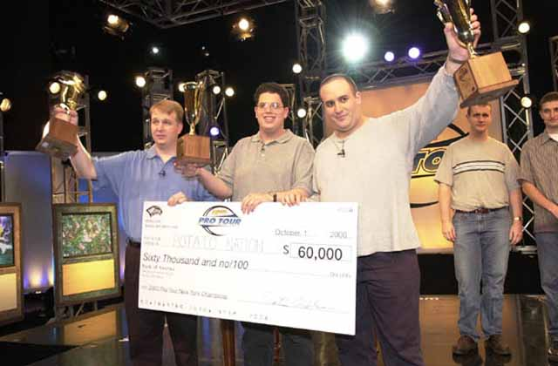
Potato Nation: Mike Turian, Scott Johns and Gary Wise: Win a PT and things change. All of a sudden, the members of the Nation have all been vaulted into PotY contention, not to mention good standing in the Mindripper Power Rankings. While Scott and I had our rough moments after New York, that's all been smoothed out. Those of you making the trip to Boston should find PN eager to take advantage of one of their few get togethers prior to Tokyo.
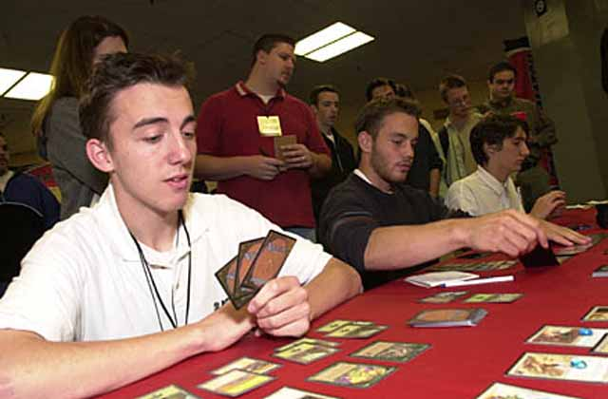
Black Ops: Antoine Ruel, Olivier Ruel, and Fleurent Jeudon. Winners of the Team Draft Challenge last may, the Black Ops have played together more than any team in this field and know each other well. The Frenchmen got the Challenge spot by winning the French teams league, which gives them a distinct advantage in the amount of practice they get in. With both Ruel's beginning to pile up individual accolades, they'll be out to show where their roots are.
Outland: Bjorn Jocumsen, Eivind Nitter, Nicolai Herzog. 5th place finishers at PTNY this year, Outland didn't play in DC, so their birth here comes mostly thanks to that strong finish. Of the three, Herzog, a former European Champion and Invitational invitee, is obviously the best known of the three, but Eivind is having the best year of the three, with money finishes at each of the PT stops thus far.
If the present ratings hold form, these four teams can't play one another. Their potential opponents, along with the winner of the gateway, are:
Team Game Empire: Alan Comer, Kurt Burgner and Brian Selden. With eight individual Top 8 finishes between the three of them, these players prove to be one of the more impressive teams on the Tour, but there are a lot of questions to ask. Comer, one of the Tour's all time greats, recently fell of the gravy train and is making the trip just for the Masters. Burgner, who showed up in LA after a prolonged absence, doesn't seem to be playing as much as he used to, and the three likely won't get that much practice in. Runners up at PT DC, they've shown they can do it in the past. The question is whether they can do it in the present.
Panzer Hunters: This top team from Japan won a team Pro Tour Qualifiers and came second in another one, boosting their rating high-enough to receive an invitation. The team is made up of three Pro Tour veterans from Japan.
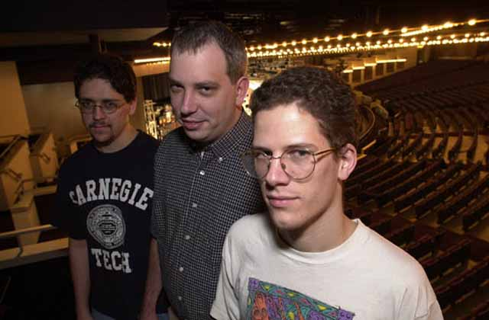
Car Acrobatic Team: Aaron Forsythe, Andrew Cuneo, Andrew Johnson. Coming second to the only team, Potato Nation, that beat them all weekend, Car Acrobatic Team steamrolled through the rest of the opposition, leading the Swiss most of the way. Led by the popular Forsythe, who had a great year in 2000, CAT will likely once again prepare with Potato Nation's Mike Turian. The big question here is whether they'll get a chance at revenge.
That's it for this week guys. I'll be back in seven days with another look at the PT, updates on Tokyo preps and some other stuff. As always, send your questions and comments to JGaryWise@yahoo.com. Good luck in Cologne and Boston.

